**[Email for Monday, Sept. 18]**

**[Subject: Caring Campaign: Only Two Weeks Left!]**

**Team,**

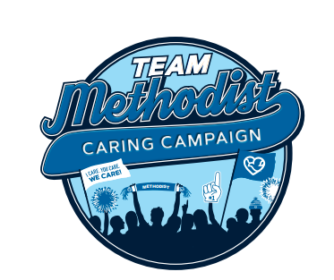

**Methodist employees take care of each other.** Our participation in employee giving campaigns is more than twice the national average.

During Caring Campaign, every donation you make, large or small, will help others in need, including our co-workers facing financial emergencies.

**Mike**, an RN at Methodist, benefitted from Caring Coworkers Fund during a tough stretch financially. He wanted to express his heartfelt gratitude for your support.

**[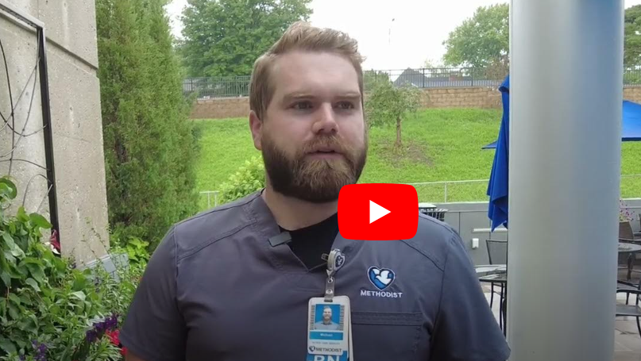](https://www.youtube.com/watch?v=kjrAPTNke8A)**

**Thank you, Mike!**

**We are now halfway through Caring Campaign.** If you’ve already made your pledge, thank you! You’re automatically entered into our weekly gift card drawings.

**If you haven’t made your gift yet**, either turn in your paper pledge form or go online to our [Methodist Intranet](https://nmhs.service-now.com/esc?id=sc_cat_item&table=sc_cat_item&sys_id=ef68e3eb1b57651085ccc80f034bcbdc).

Thank you for showing the community how we care for each other here at Methodist. Let’s finish strong!

[Signature]

**For more information about Caring Campaign, more videos and a fun photo gallery, visit** [Methodist Hospital Foundation](https://methodisthospitalfoundation.org/caringcampaign2024).