**[Email for Monday, Oct. 2]**

**[Subject – Caring Campaign Deadline Extended!]**

**Team,**

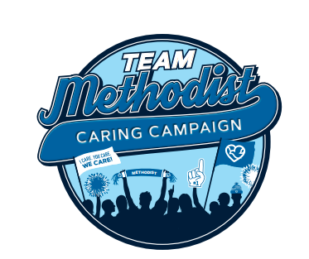

During a time when so many people are struggling, we can’t support our co-workers and our community enough. That’s why we’re extending Caring Campaign until **Friday, October 6,** an extra week to encourage as much participation as possible.

You were there for Lisa and her family when they needed it most. She wants you to know how much your support meant to her.

**[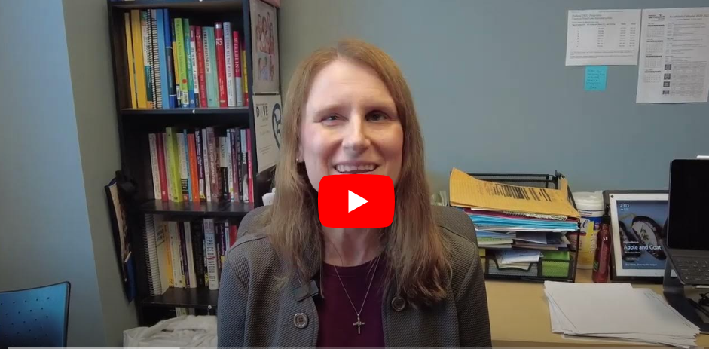](https://www.youtube.com/watch?v=CIy440IVyzg)**

**Thank you, Lisa!**

**Please get your pledge in. Help our department reach 100% participation.**

[Click here](https://staff.bestcare.org/caring-campaign-quick-gift-form) to make a quick gift.It takes about 10 seconds – and you’re automatically entered to win one of ten $50 gift cards each week!

Every gift – large or small – makes a big difference. It’s what we do together that counts.

**Thank you for your participation.**

[Signature]

**For more information about Caring Campaign, more videos and a fun photo gallery, visit** [Methodist Hospital Foundation](https://methodisthospitalfoundation.org/caringcampaign2024).