**[Email for Monday, August 28]**

**[Subject: Huddle Up, Team!]**

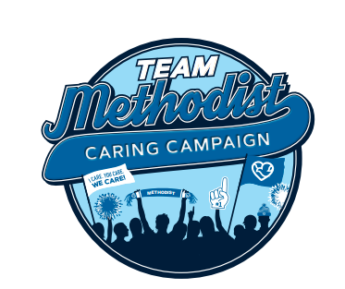

**Caring Campaign** **officially starts on Friday.** This year’s theme is Team Methodist. It’s a celebration of what we do every day – huddling up to help our patients, coworkers and communities. **When we support each other, everyone wins!**

Throughout the month, you’ll be hearing a lot about the [**Caring Coworkers Fund**](https://methodisthospitalfoundation.org/caringcoworkers) (formerly Family Crisis Connection). The new name is a tribute to you. Your support during Caring Campaign makes this fund possible – money that can help your coworkers get through financial emergencies.

No matter the size, your gifts make a difference. Most important is your participation in Caring Campaign – that’s what really counts.

**We need everyone in the game.** Either turn in your paper pledge form or go online to our [Methodist Intranet](https://nmhs.service-now.com/esc?id=sc_cat_item&table=sc_cat_item&sys_id=ef68e3eb1b57651085ccc80f034bcbdc).

The sooner you participate, the more chances you have to win a $50 gift card. The Foundation is drawing ten winners a week starting **Wednesday, Sept. 6.**

**Caring Campaign runs throughout September.** Thank you for considering a gift.Let’s show others what our department is all about by having great participation!

[Signature]

**For more information about Caring Campaign, more videos and a fun photo gallery, visit** [Methodist Hospital Foundation](https://methodisthospitalfoundation.org/caringcampaign2024).